Question 1

CODE

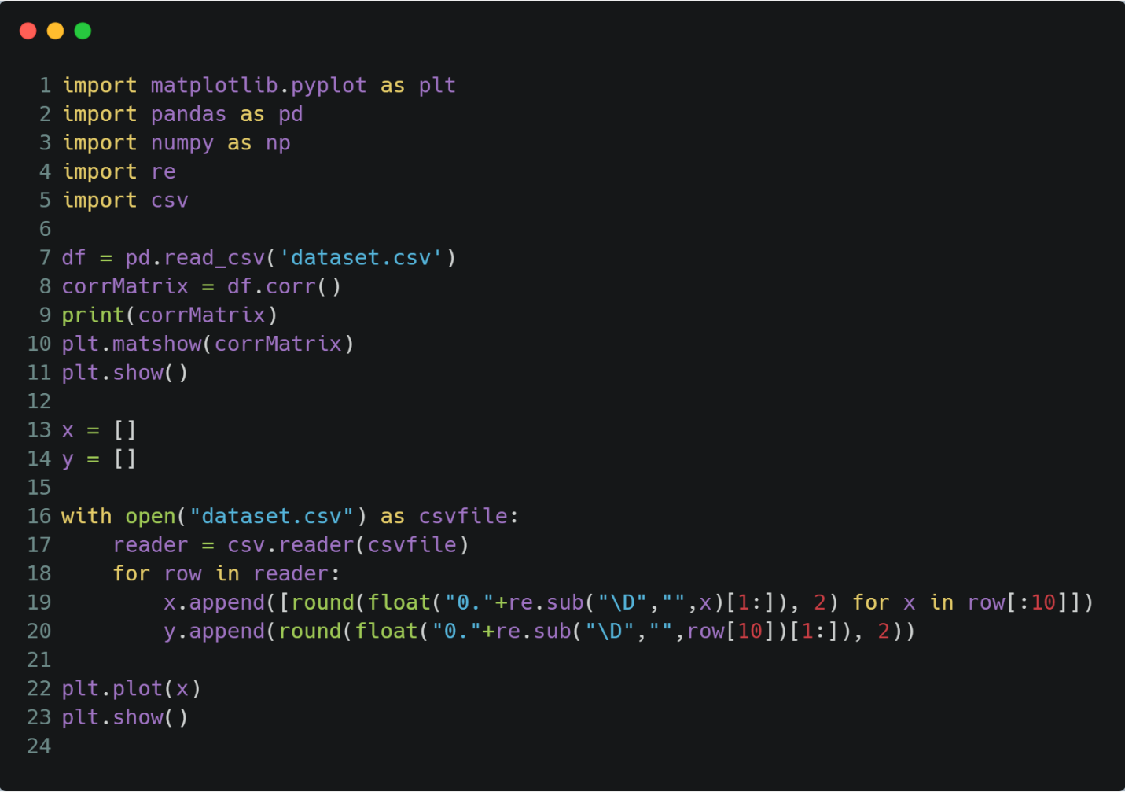

OUTPUT

Correlation Matrix

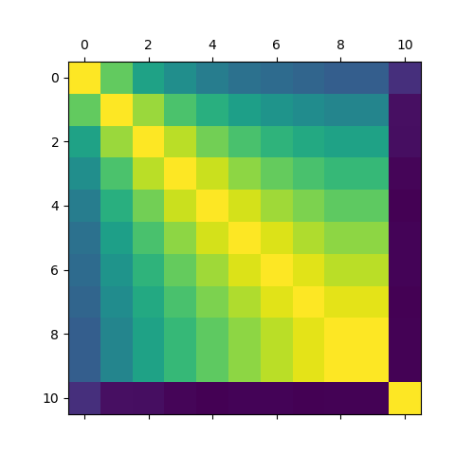

Redundant Data / Data anomalies

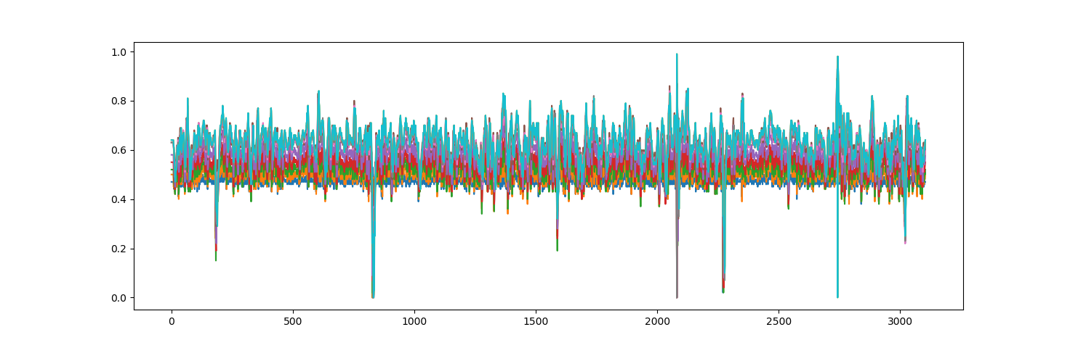

Question 2

CODE

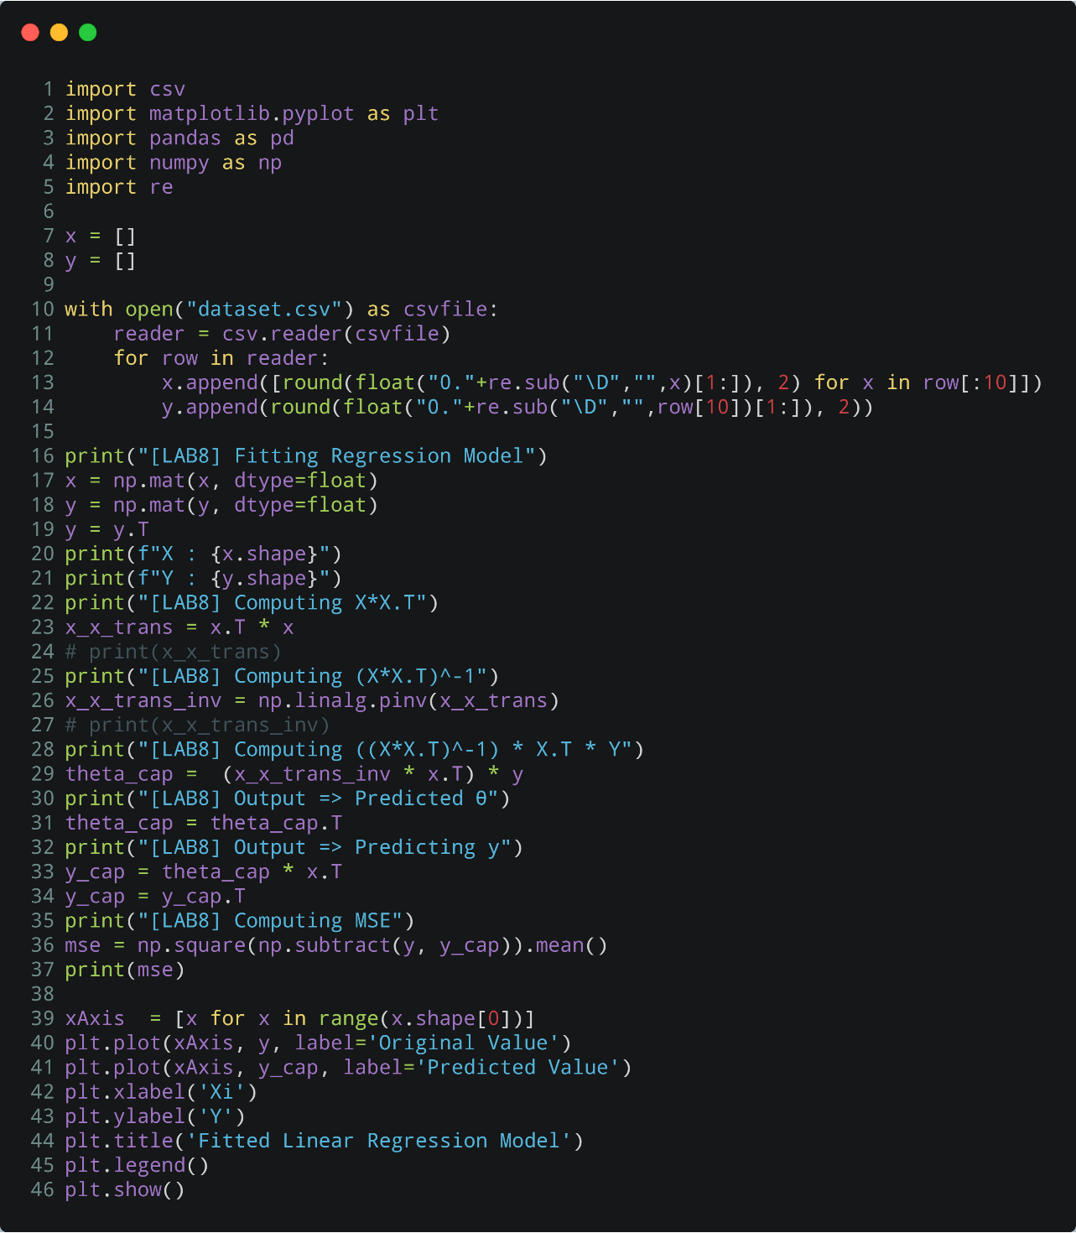

**OUTPUT**

[LAB8] Fitting Regression Model

X : (3105, 10)

Y : (3105, 1)

[LAB8] Computing X*X.T

[LAB8] Computing (X*X.T)^-1

[LAB8] Computing ((X*X.T)^-1) * X.T * Y

[LAB8] Output => Predicted θ

[LAB8] Output => Predicting y

[LAB8] Computing MSE

0.001060716646764775

